User Manual

*April 17*

*Version 2*

*Northwest Missouri State University*

*Graduate Directed Project – II*

*Crazy Coders*

Table of Contents

1.0 GENERAL INFORMATION

1.1 System Overview

1.2 Organization of the Manual

2.0 SYSTEM SUMMARY

2.1 System Configuration

2.2 User Access Levels

2.3 Contingencies

3.0 GETTING STARTED

3.1 Installation and Logging In

3.2 System Menu

4.0 USING THE SYSTEM

5.0 REPORTING

1. Introduction

Our mobile Application is intended to help you to access the information about the university campus maps for the buildings more quickly and efficiently. After installing the Mobile App, you will be able to:

• Review the University location and map

• Get the tour of the campus and the building in the campus.

• Scan the QR Code and

•

•

1. Process Overview
2. Selecting the campus and downloading the map:

* Launch the application.
* Click the on the drop down menu to select the university of your choice.

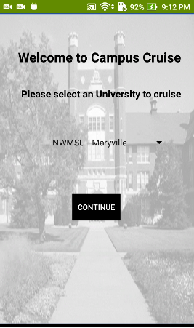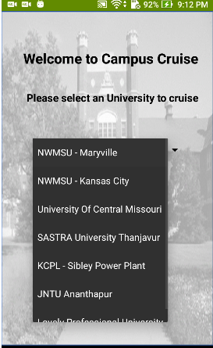

* The application will download the map of the university.
* The application will display an alert if the is any interruption during the process.
* Once the data has been loaded, the application will display your location.

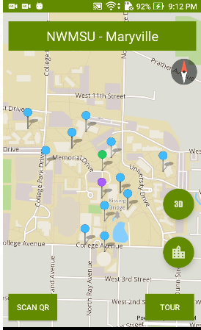 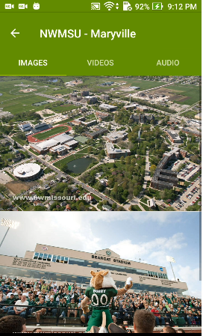

* There are videos and audio for the university if the tabs are clicked.

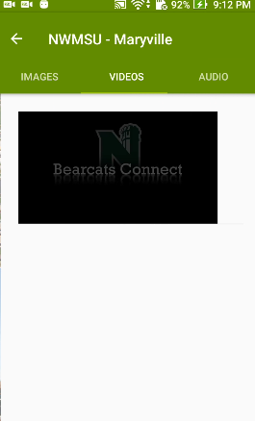 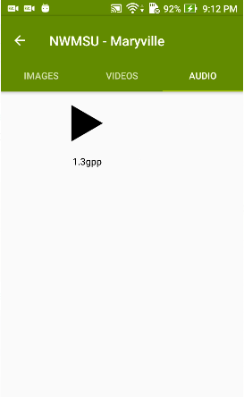

* The list of buildings in campus are displayed when the university is clicked

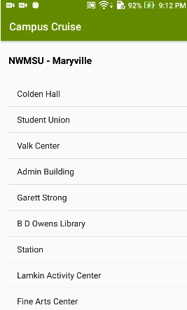

* Click on B.D Owens library or any other building the page open for that particular building

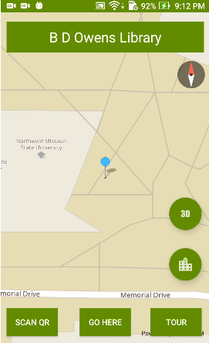 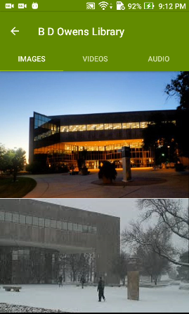

* If go here button is clicked it shows the route to that building and displays a message once reached there.

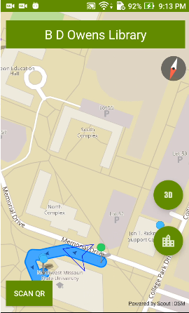 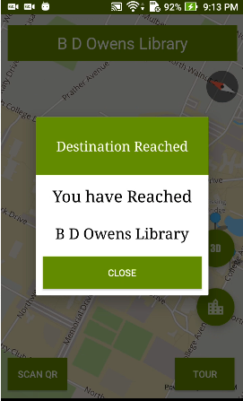

* After reaching the building closing the popup msg another screen is displayed asking to read the QR or continue with the tour

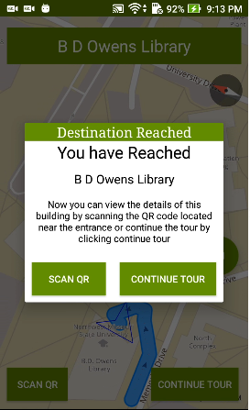 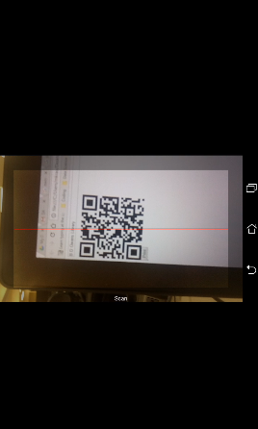

* When clicked on scan QR code the below screen is displayed which scans QR and displays the details

 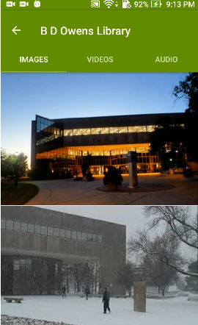

* If continue tour is clicked then it continues to the next building nearest.

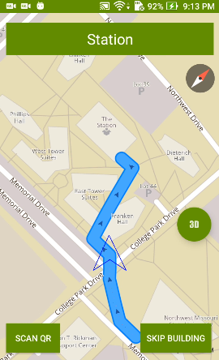

1. Visual tour:

* When you click on the Virtual Tour button.

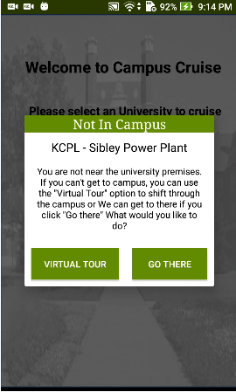

* When clicked on virtual tour a new window opens

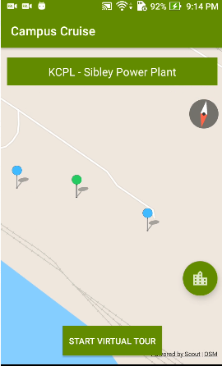

* Application will load the map, and display the campus overview.

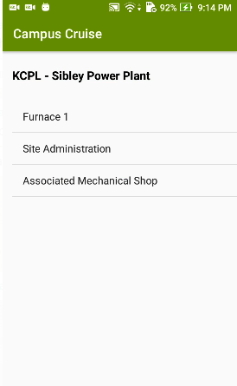

* The overview will contain all the buildings of the campus and a path form one building to the other.



1. Campus tour:

* When you click on the Campus Tour button, the application will start the campus tour.
* The application will show the user location on the screen.
* The application will show the user the path to the next nearest building.
* When the user reaches the next building, the application will alert the user to scan a QR code.

1. Scanning a QR code:

* Click on the menu button on the top left corner of the application.
* Click on the Scan QR code button.
* Scan the QR code using the camera.
* The application will scan the QR code and display the data related to the QR code.

1. Use of the Web Application

* The web application connects the application to the MYSql Database. The admin adds the buildings list to the universities and adds new universities to the list.
* The home screen is below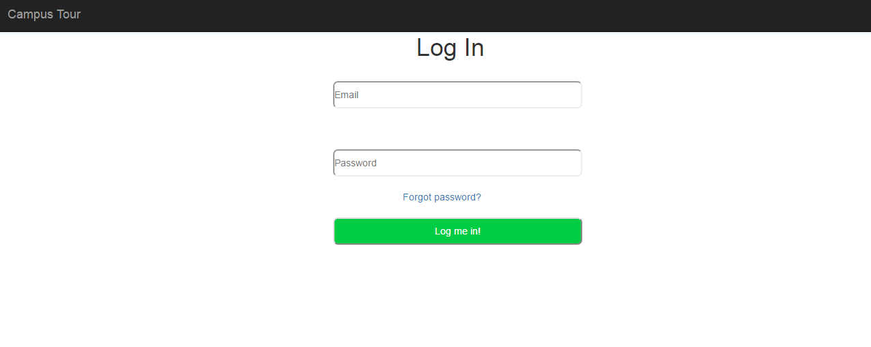
* After Successful log in the home screen is shown where the buildings list is shown and a new building can be added when clicked on the Add building link

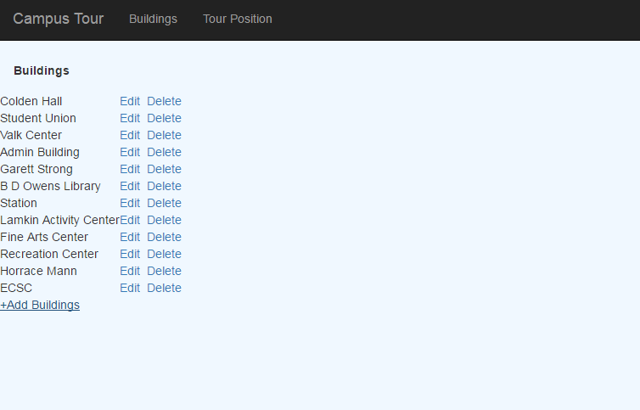

* When Add building is clicked then the following screen gets opend

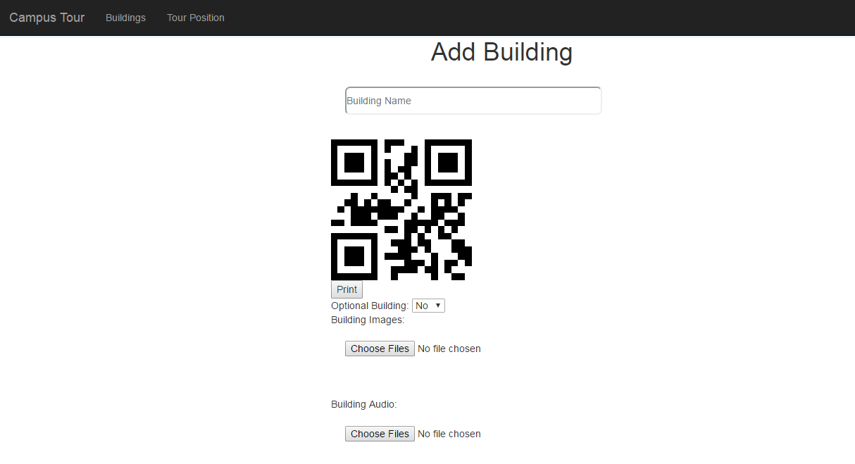

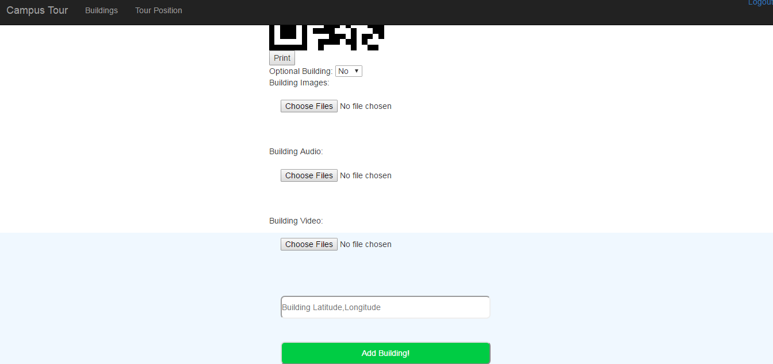

* And a new building can be successfully added
* When edit link is clicked beside the building name the screen is displayed to change the name and the coordinates.

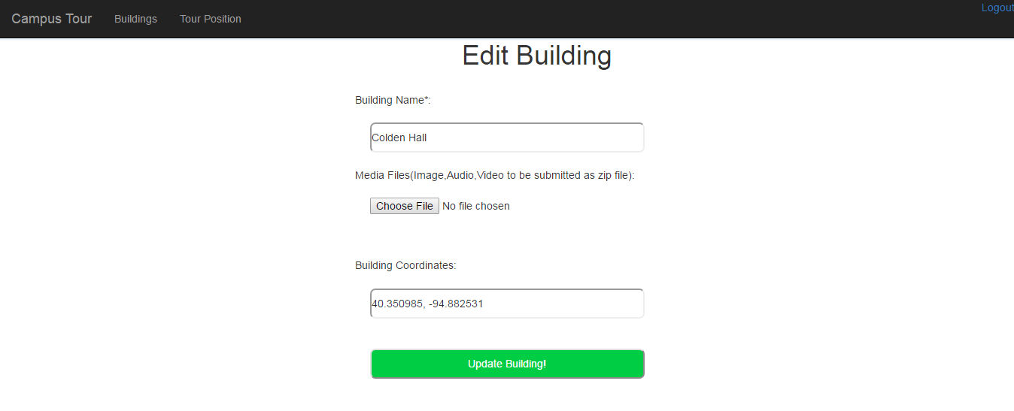

* When tour position is clicked the order of tour buildings can be changed.

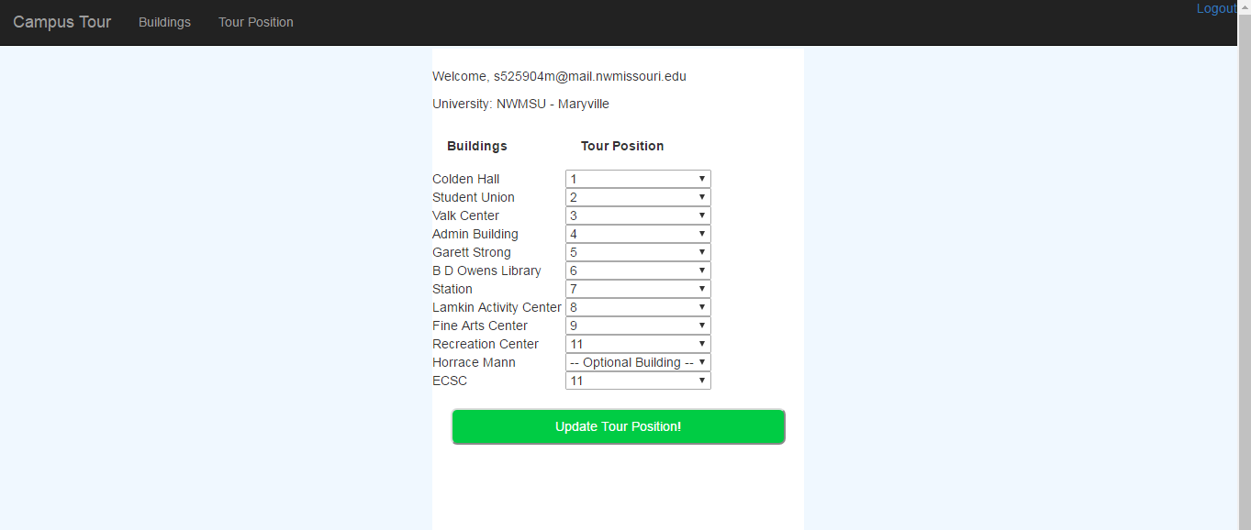

Add Universities:

* Add university login using different credentials of admin using the same screen.

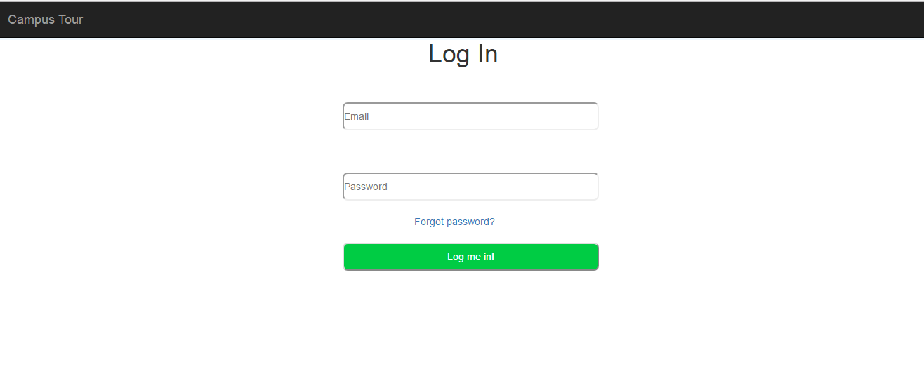

* Here the admin can add universities in the screen below

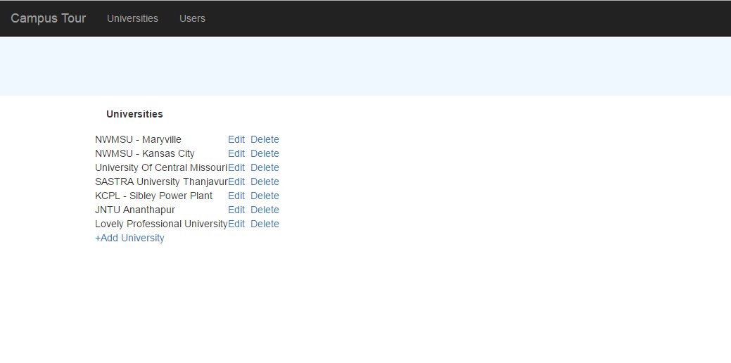

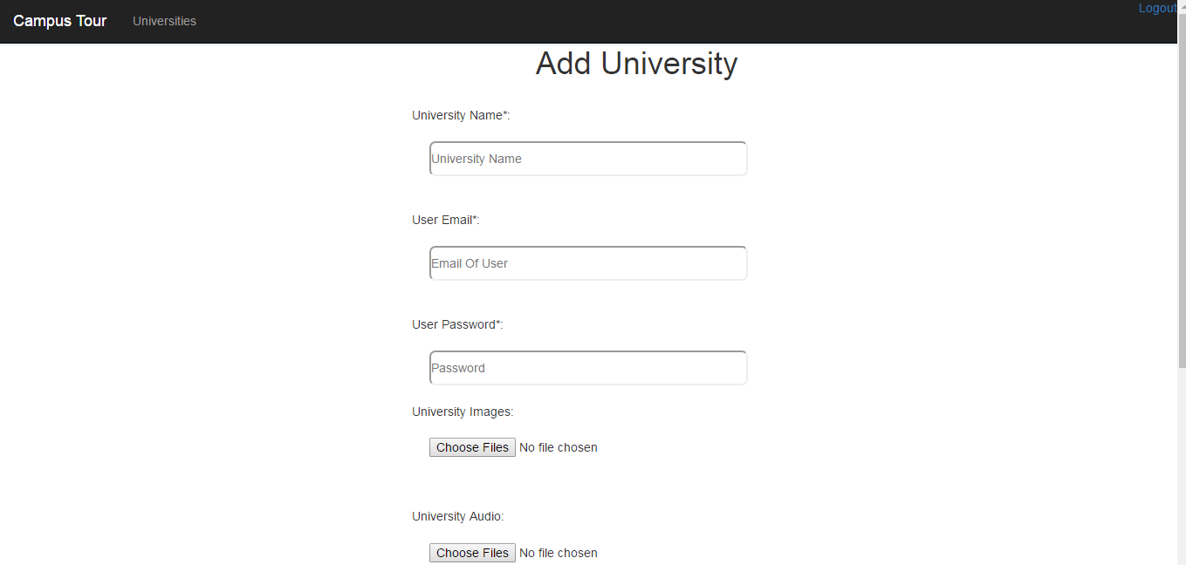

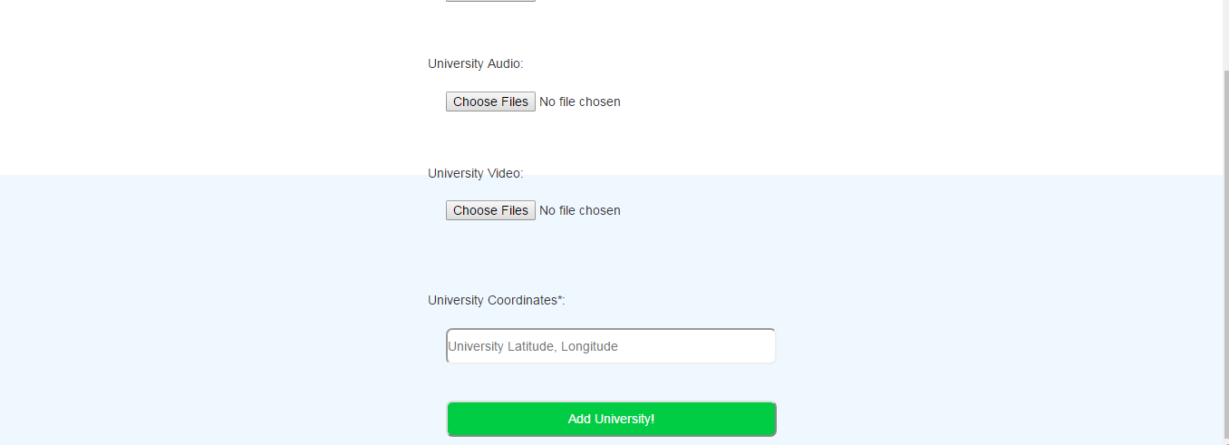

* Admin can delete and edit the universities as well.

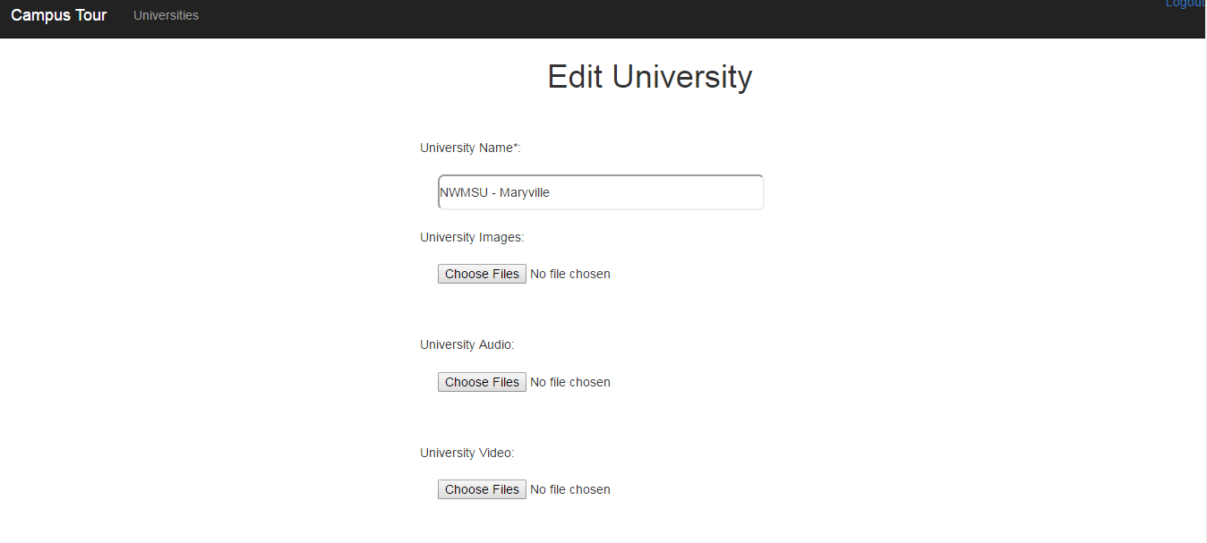

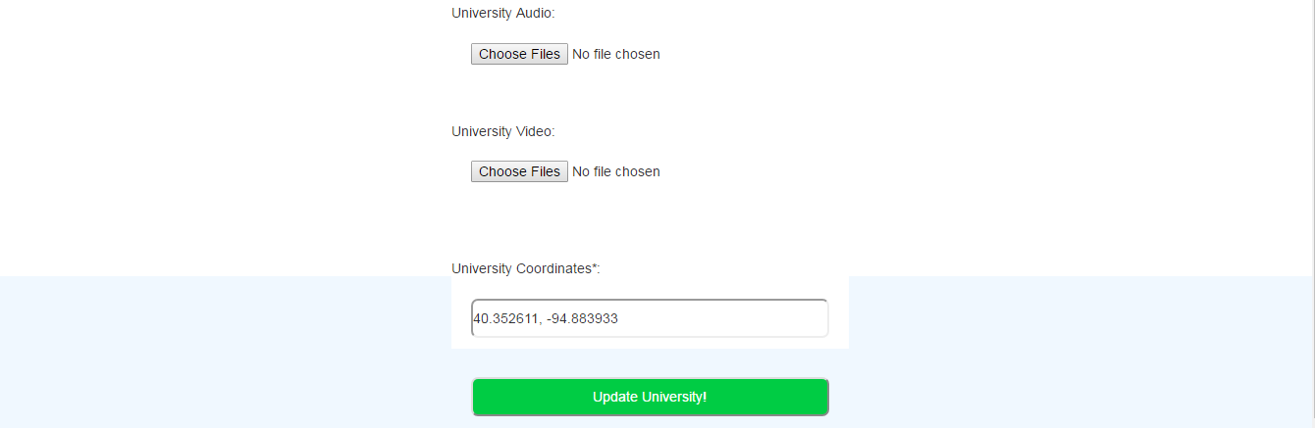

Thus the application can be run and used manually.